**Project Design Plan**

1. Purpose

The project is to design web and mobile interfaces for a Yard Management Service System. The potential users are ship clerks at dock doors (web interface) and security guards at facility gates (mobile interface). This service provides real-time tracking and management for transportation vehicles in warehouse facilities.

1. Site Map

The home page is a ship clerk dashboard page. There are two versions of guard shack apps (i.e., mobile and web). In this project, only mobile interface design is introduced. Besides, there are location configuration and admin setting pages.

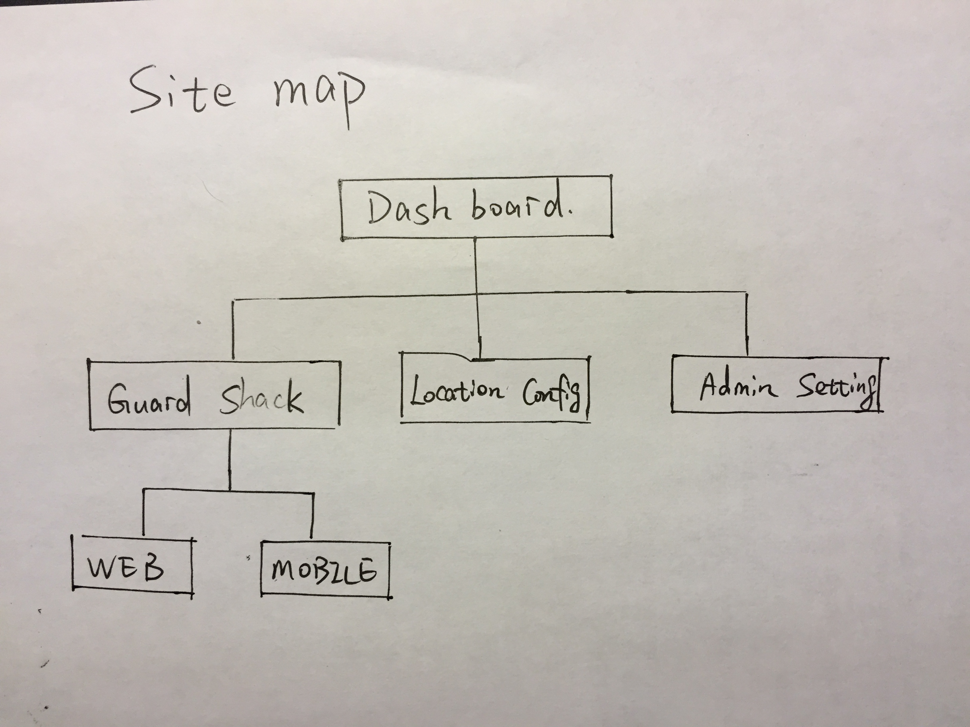

1. Wireframe

Web: Option A is chosen for thumbnail for dashboard page.

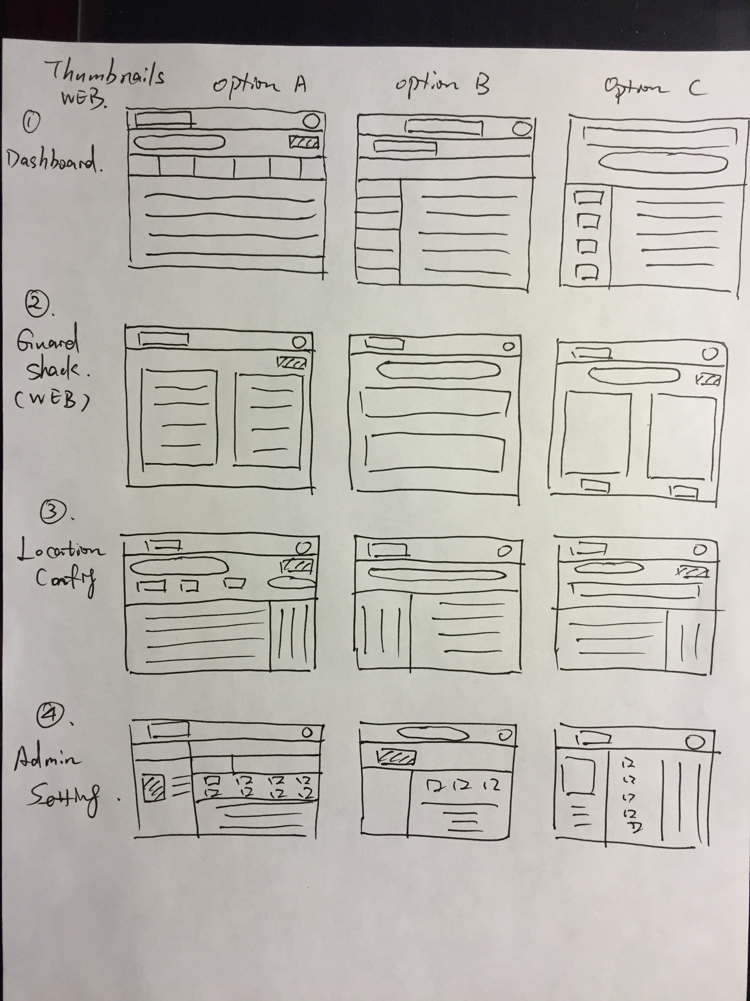

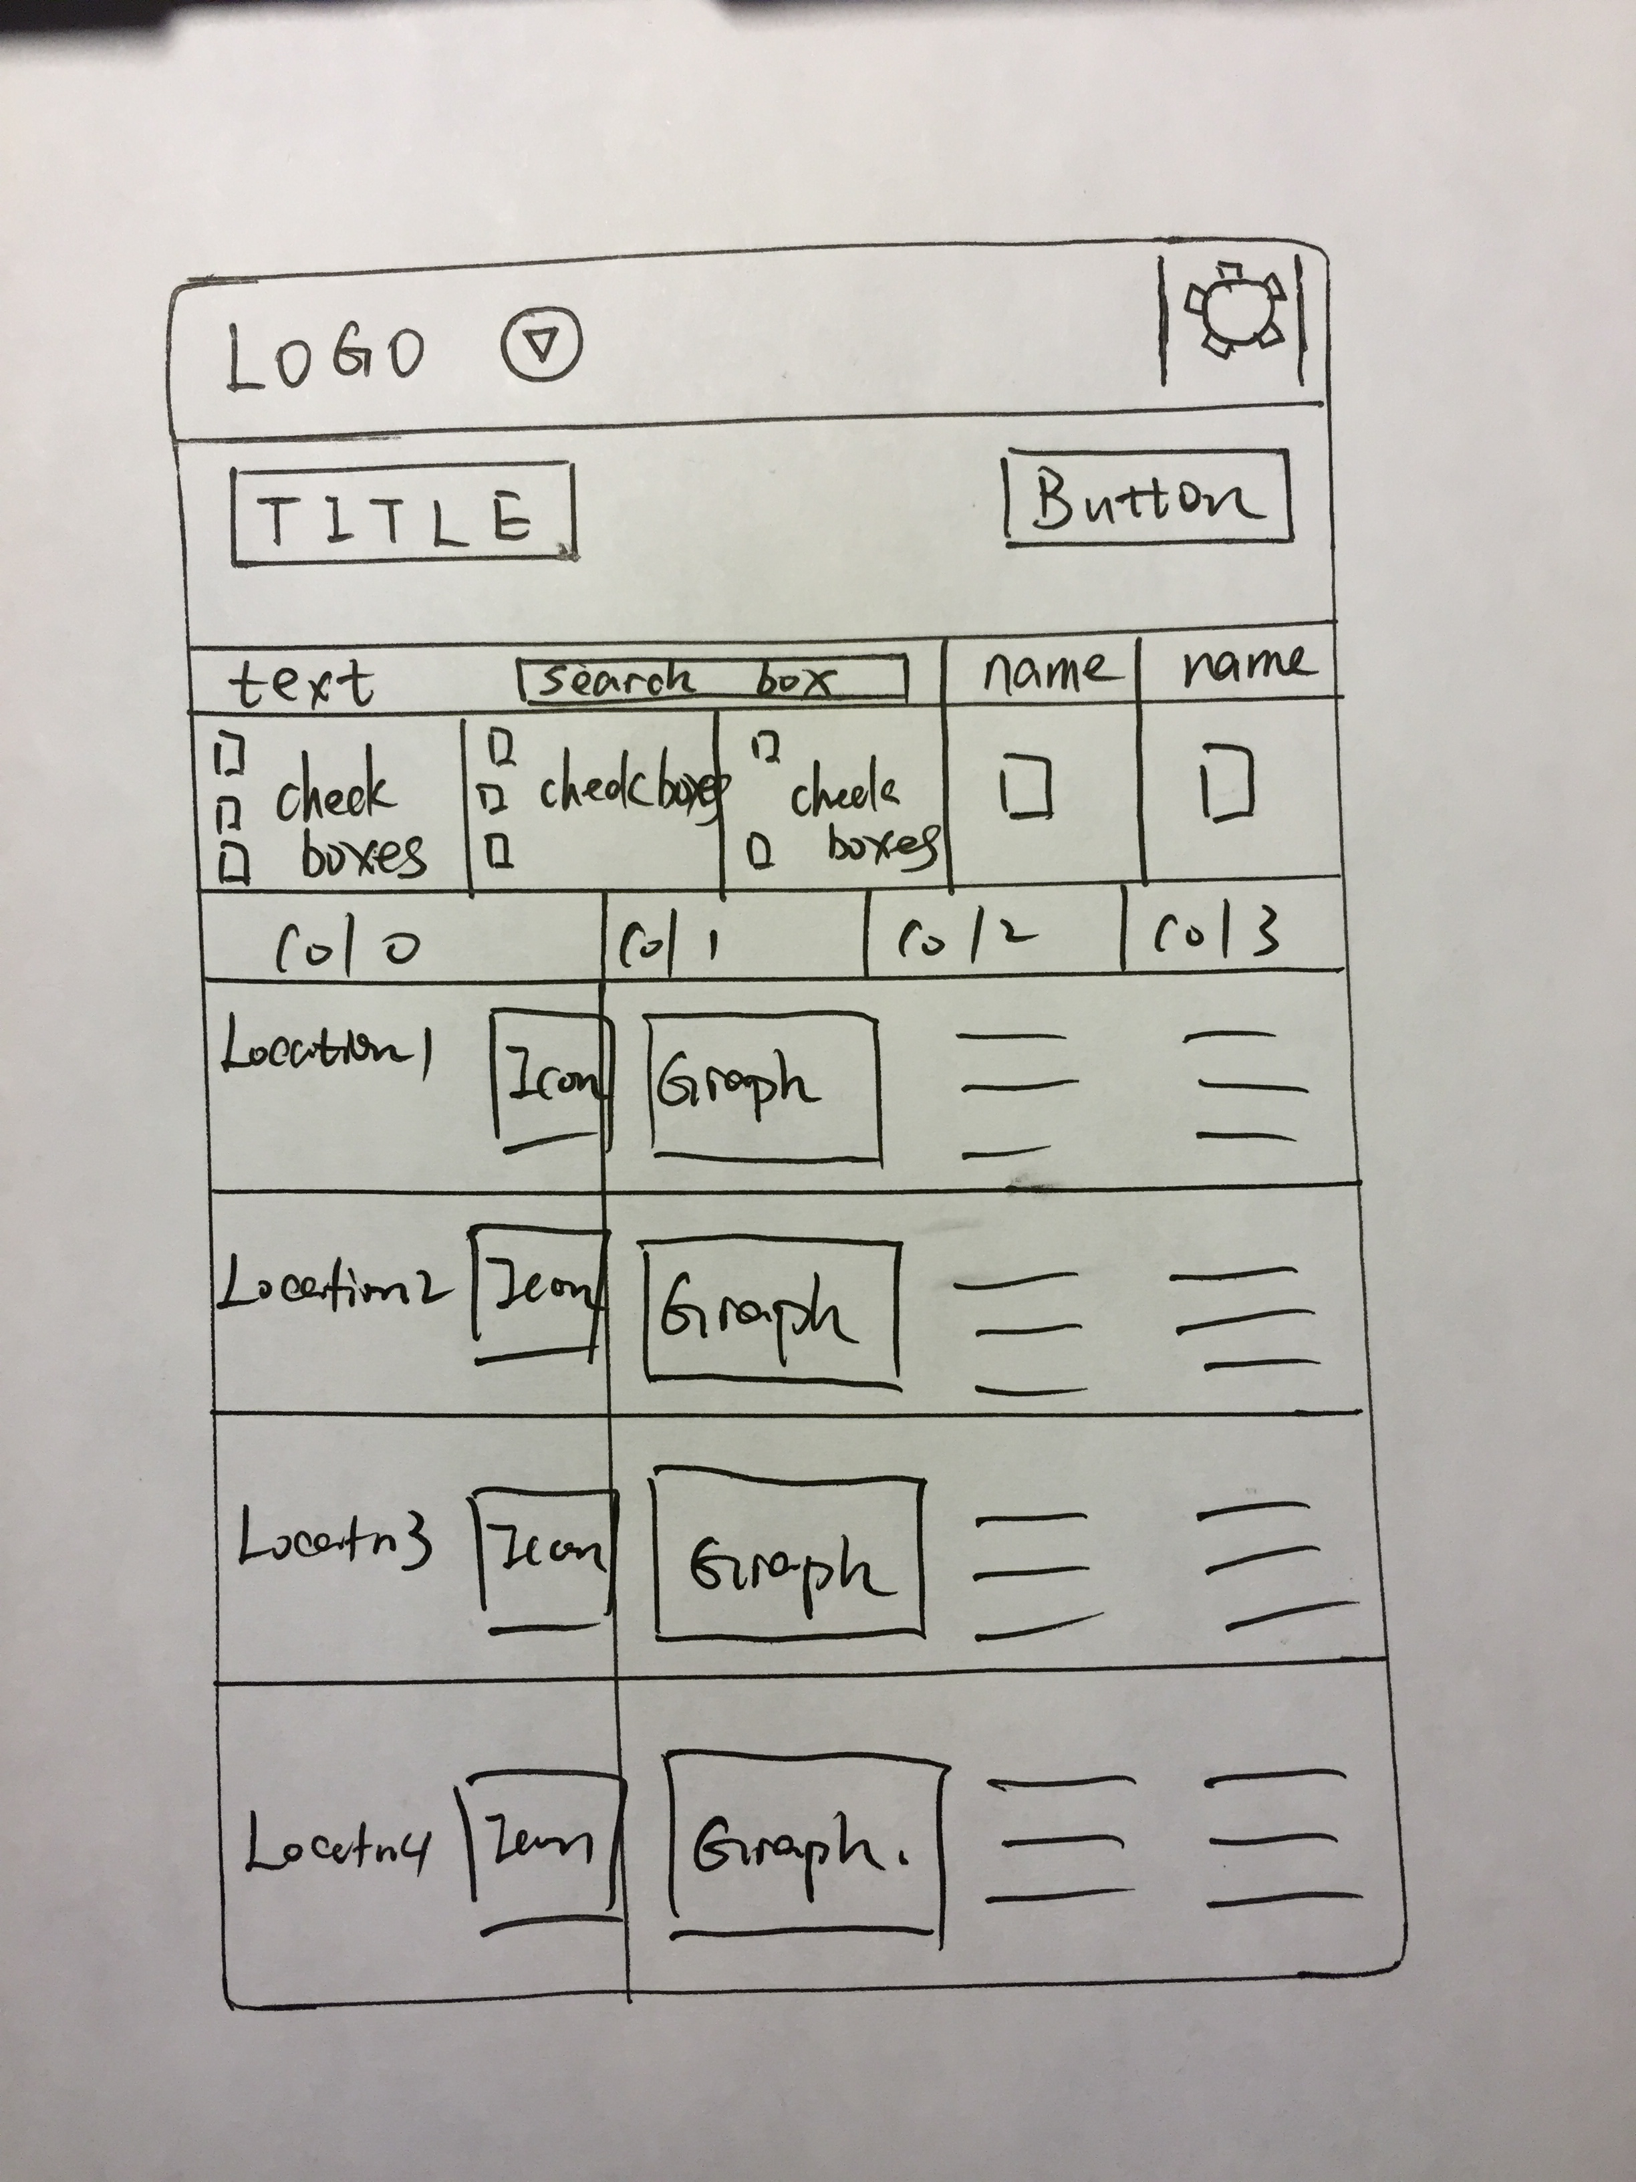

Mobile: Option C for Login screen; Option A for appointment list screen.

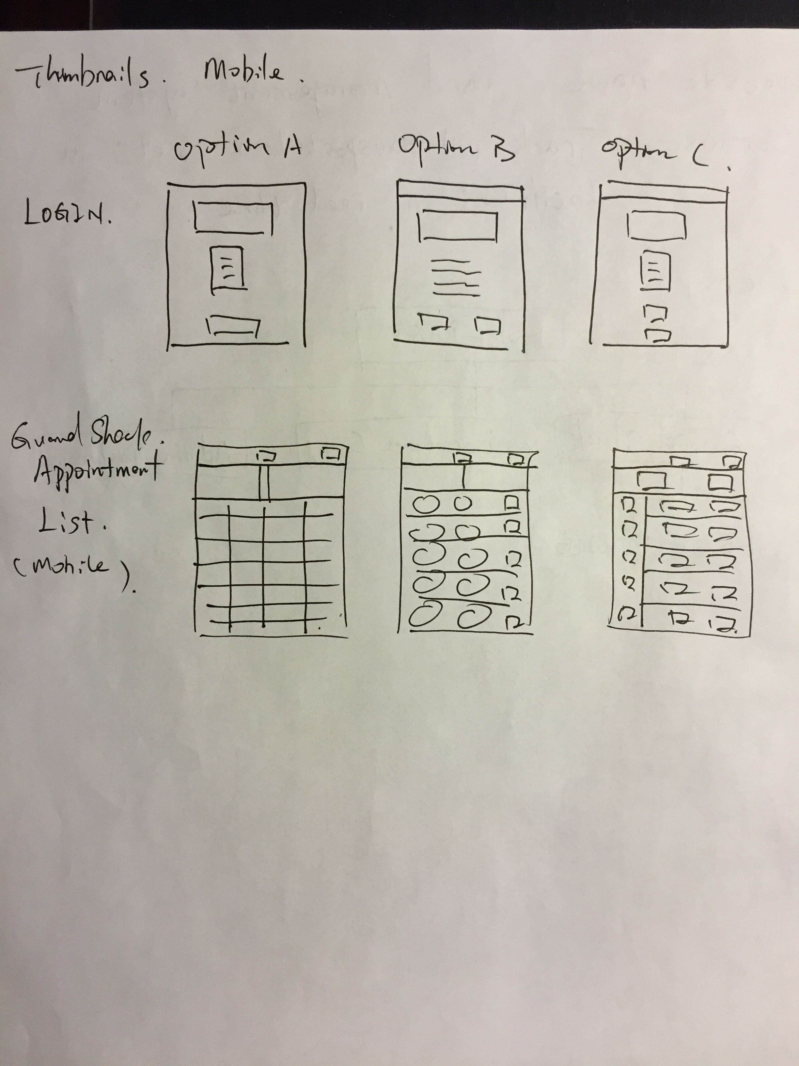

1. Mock-up sketc­­hes

Web:

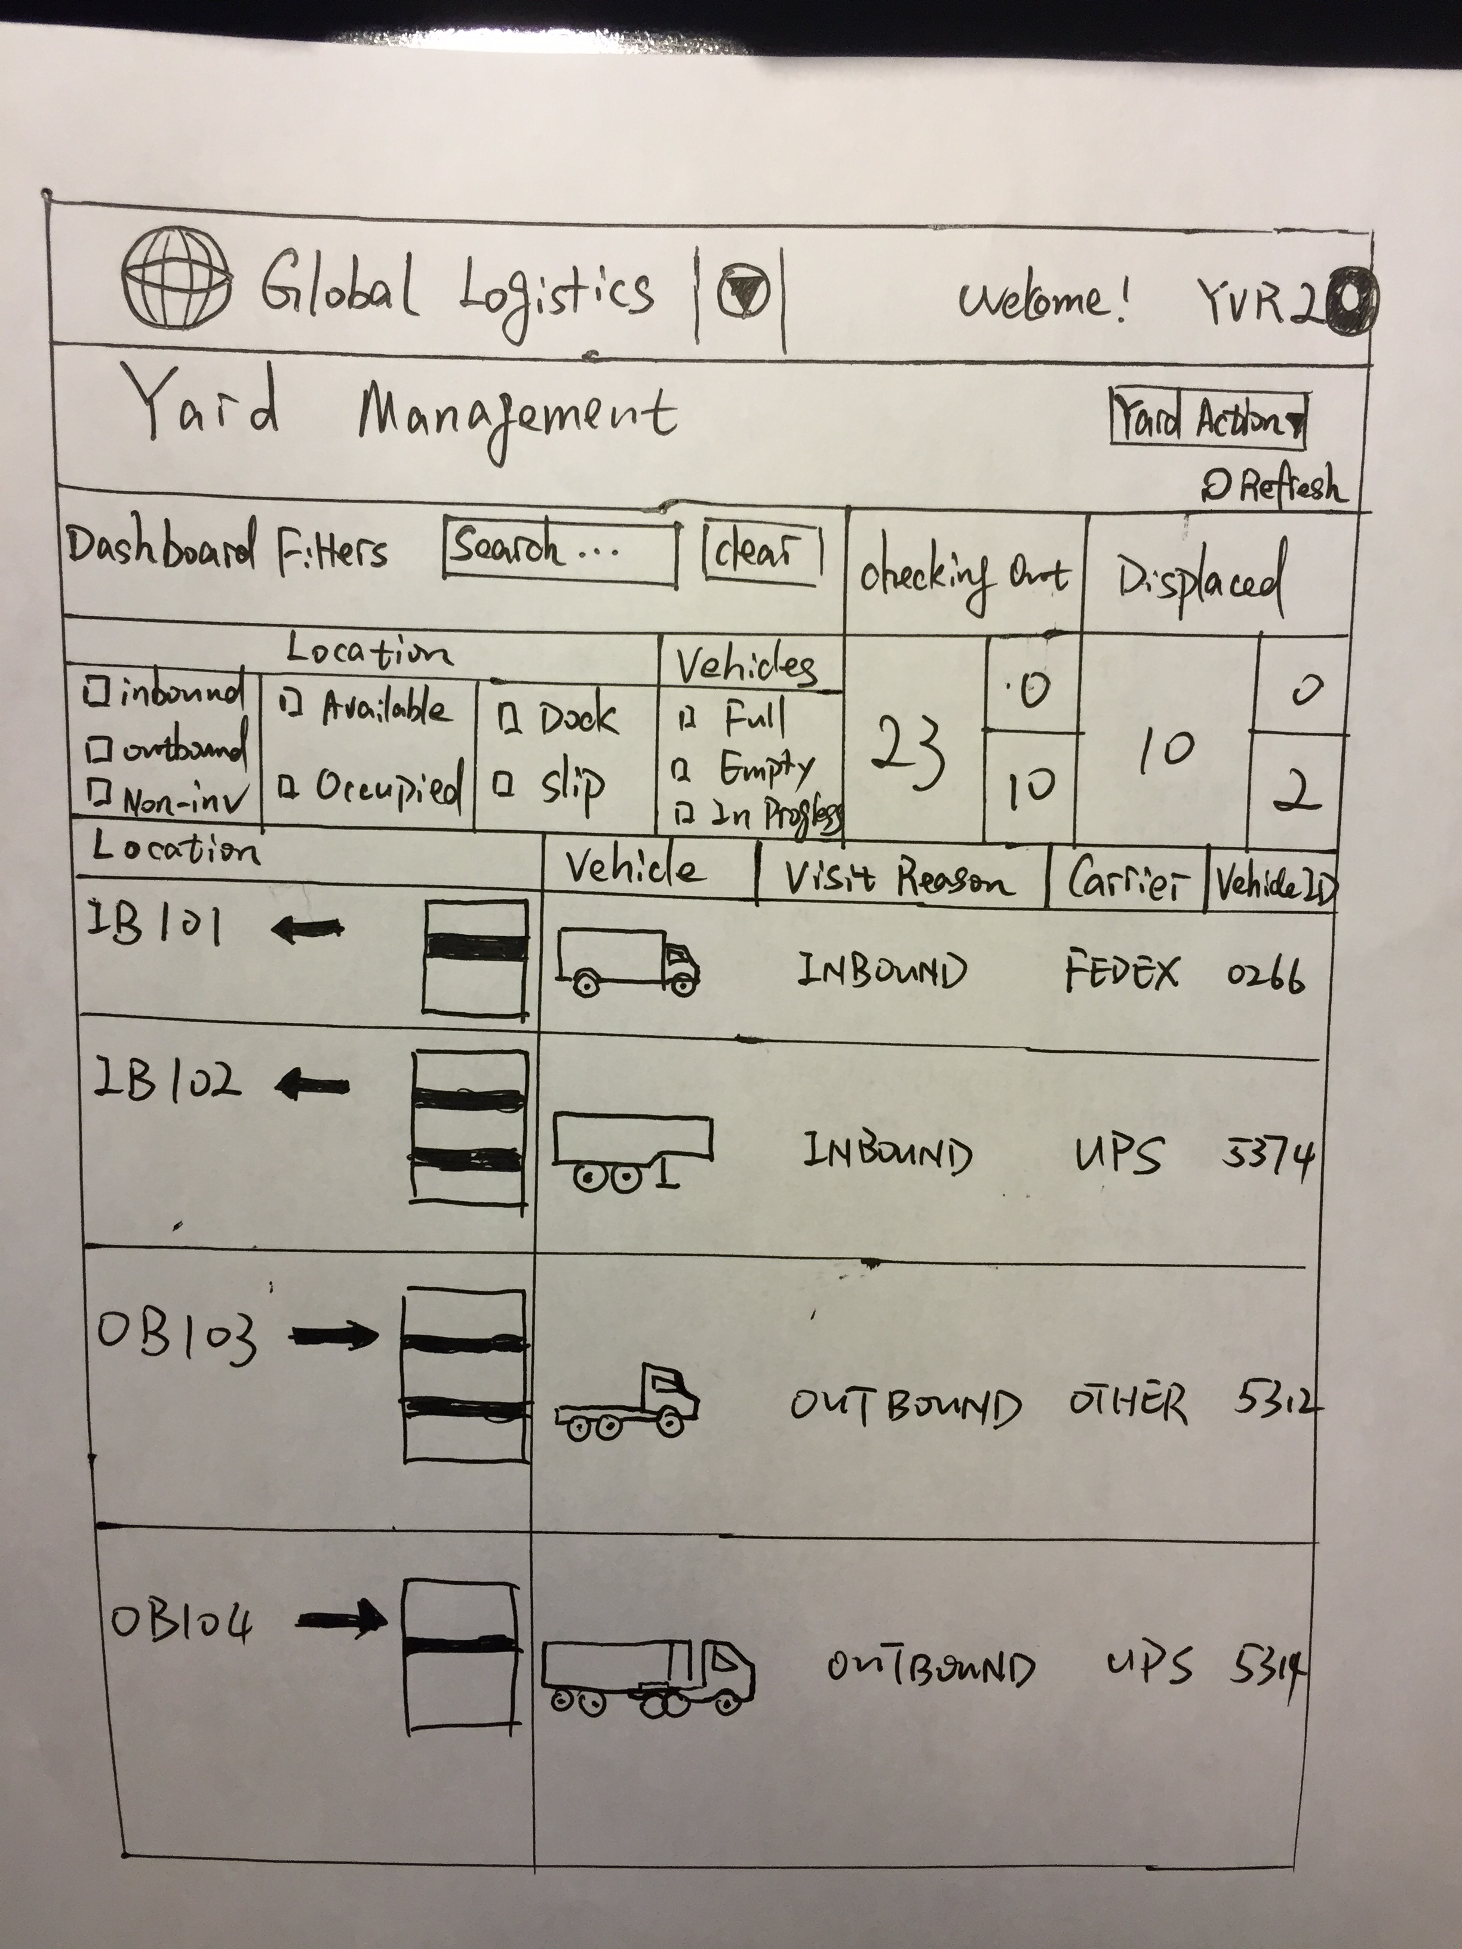

Mobile:

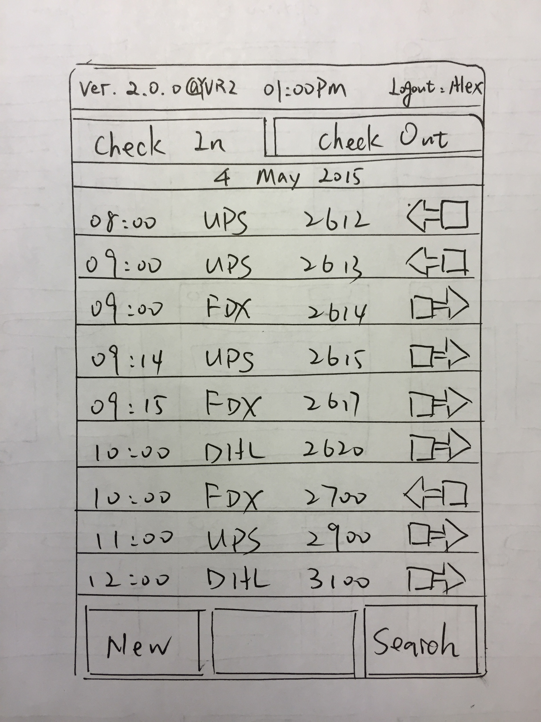

1. Element List

Web:

Background

Banner

Button: Admin setting

Business name

Logo

Topbar

System name

Button: yard action

Button: locale

Textbox: serach

Button: clear

Button: summary view

Image: dock

Image: dock_double_decker

Image: trailer

Image: tractor

Image: box_truck

Other directional devices include:

Scroll bar

The numbers under “Checkout” menu are clickable.

Animation:

Image of box truck has three status: empty, in progress, and full.

Mobile:

1. Login Screen

Background

Business name

Logo

App name

Device info

Button locale

Text locale

Button scan

1. Appointment Lists Screen

Background

Version and location

Logout

Time

Main container

Horizontal bar

Tab checkin

Tab checkout

Text checkin

Text checkout

Bottom box

Button new

Button search

Textbox search

Appointment row 1

Time1

Time2

Carrier1

Carrier2

Load1

Load2

Inbound icon

Outbound icon

No vehicles icon

Button next

Text new

Text search

Text next